ANALYZING CONSUMERS’ FASHION ORIENTED IMPULSIVE BUYING BEHAVIOR AT E-COMMERCE FASHION INDONESIA

¹ Nabila Emiralia Ginastika, and ²Harimukti Wandebori
¹School of Business and Management, ITB
nabila.emiralia@sbm-itb.ac.id

²School of Business and Management, ITB

harimukti@sbm-itb.ac.id

ABSTRACT
Nowadays, the potential market of e-commerce in Indonesia is very large. Among many online industries, fashion is still one of the most attractive B2C e-commerce in Indonesia. The reasons why people like to shop fashion are pleasure and the availability of newest collection which raised curiosity shop and buy immediately. This matter lead to the phenomenon of impulse buying where consumers make a purchase without a planned. This phenomenon grow rapidly as Indonesia ranked the top 3 in the number of consumers who make impulse buying. Since there are also so many retailers, it is pivotal for retailers to understand customers’ impulsive buying behavior toward fashion online industry as prior studies to analyze consumers’ behavior in this competitive business environment. This research aims to determine what factors are causing consumers to do impulsive buying and how these factors effect on impulsive buying toward fashion products at ecommerce fashion Indonesia. This research used quantitative method. Variables examined in this research include fashion involvement as independent variable, positive emotion and hedonic consumption tendency as intervening variable, impulsive buying as dependent variable. The findings determine that hedonic consumption tendency has significant influence on impulsive buying toward fashion products at ecommerce Indonesia both directly or indirectly. Meanwhile, fashion involvement and positive emotion have significant influence on impulsive buying toward fashion products at e-commerce indirectly.

Keywords: fashion online, fashion involvement, hedonic consumption tendency, positive emotion, impulsive buying

BACKGROUND
Since the rapid changes of technology, social networks and other online medium, consumers are more pro-active toward shopping activities. Consumers tend to have more ability to seek the clarity and genuineness about the companies they do transactions with. One of the industries that take a big part to use online medium to reach its customers is fashion. According to (stratupbisnis.com, 2014), among other industry, fashion is still one of the most attractive B2C e-commerce in Indonesia, which most widely purchased by 78%, then the mobile (46%), electronics (43%), books and magazines (39%) and groceries (24%). When buying fashion products consumer prefer to try first, touch, and feel before buying (Phau & Chang-Chin, 2004). This experience is impossible to get online. However, research found that consumers seen Internet as alternative for shopping fashion products, they are more tend to buy impulsively through that media (Phau & Chang-Chin, 2004). Impulsive buying made by consumer is not something new to marketing. Impulsive buying made by consumer is not something new to marketing. Impulsive buying happens both in offline store and online (internet).
Impulsive buying has been a topic of research since 1987 by Dennis W. Rook. This phenomenon is then growing especially in the context of online on e-commerce transactions. In fact, 40% of online transactions are impulsive buying (Liu, 2002). Nevertheless, in some studies there are still limited to certain subject areas. For example, in the study "Online Impulse Buying: Understanding the Interplay between Consumer Impulsiveness and Website Quality" which examines impulsive purchases on B2C commerce coverage (Wells, Parboteeah, & Valacich, 2011) or “External and Internal Trigger Cues of Impulse Buying Online” which describes the process of impulsive buying behavior by a consumer in online context (Dawson & Kim, 2009). This showed that phenomenon of impulse buying on the internet (online impulse buying) is not a new thing. Yet, the phenomenon of impulsive buying on the internet which focus on fashion products is interesting to be discussed.
The problem underlying to this research is although women cannot experience the true fashion shopping experience while shopping online, but the fact remains that impulsive buying is likely occurring on fashion online shopping. On the other hand, there is no specific research about this phenomenon. To be able to rise to the phenomena of impulse buying marketers must determine the factors that influence consumers in making impulse buying. Therefore, the objective of this research is analyzing consumer’s factors toward impulsive buying fashion at ecommerce fashion Indonesia. By analyzing consumer’s factors toward impulsive buying at ecommerce fashion Indonesia, the researcher takes a deeper understanding of consumer behavior in online shopping environment. In order to overcome the objectives as well as solving the problems, the identified research question are (1) what are the factors that influence customers to do impulsive buying toward fashion products at ecommerce fashion Indonesia and (2) how does the relationship between the factors that influence customers to do impulsive buying toward fashion products at ecommerce fashion Indonesia.

LITERATURE REVIEW
(Rook, 1987) stated that customer experiences encouragement, persistent, and spontaneously to buy something are the tendencies when impulsive buying happens. Moreover, impulse buying is less susceptible to the consequences (Rook, 1987) and less possibility to evaluate their purchasing decisions on the typical shopper information (Jones, Reynolds, Weun, & Beatty, 2003). Thus, impulsive buying can be defined as the purchasing decisions made by consumers without any plan or intention to buy. Impulsive buying has been immigrated from traditional (conventional store) to online medium. Online consumers are also more likely to be impulsive rather than traditional consumers (Donthu & Garcia, 1999). According to (Dittmar, Long, & Meek, 2004), the features of online transactions make consumers tend to do more spending as well as unplanned buying than those in the conventional store. (Jones & Leonard, 2009) stated that the tendency of impulsive purchases or impulse-buying tendencies (IBT) is defined as the level or degree of an individual with the possibility for immediate purchase action, not planned, and unreflective. Impulsive buying tendencies related to the nature or personality of the individual against the lack of control, especially cognitive control in making impulse purchases (Youn & Faber, 2000).
Hedonic consumption tendency reflects the present instrument that directly benefit from an experience in spending (Piron, 1993). Customer’s arousal is positively associated with hedonic consumption tendency (Babin, Darden, & Griffin, 1994). Hedonic consumption tendency drew a shopping experience that provides sensory very special about the consumer’s senses. Impulsive purchases have an important role in meeting the desires associated with hedonic consumption (Hausman, 2000). This role supports the conceptual relationship between hedonic shopping motivations and impulsive buying behavior. This suggests consumers are more likely to engage in impulsive purchases when they are motivated by the desire hedonic or by economic reasons, such as pleasure, fantasy and social or emotional satisfaction.
Hedonic motives are related to the motivation factors that construct customers into the emotional condition where customers searching for benefits of enjoyment sense (Hirschman & Holbrook, 1982). These motives are regularly correlated with growing of fashion online industry since it required new appealing styles for customers (Park & Stoel, 2005). This is proved that the companies who are focusing on fashion industry should pursuit to provide exciting experience in order to reach the satisfaction of hedonic motives for their customers while they are shopping (Park & Stoel, 2005). Several researches admit that this aspect disclosed to online shopping behavior that impacted by hedonic motives (Kukar-Kinney, Ridgway, & Monroe, 2009).
As (O'Cass, 2004) stated that the involvement of the fashion associated with personal characteristics (women and youth) and knowledge of fashion influence consumers to be confident in making purchasing decisions. Consumers with higher fashion involvement are more likely to engage in impulsive purchase-oriented fashion (Park, Kim, & Forney, 2006).
According to (Beatty & Ferrell, 1998), emotions greatly influence the actions of impulsive buying. Consumers in a positive emotional state is more likely to have reduced the complexity of the decision and may decide to purchase in a short time (Isen, 1984 in Park et al., 2006). When compared with negative emotions, positive emotions showed consumer impulse purchases greater tendency for the feeling of being not restricted, the desire to respect themselves, and higher energy levels (Rook & Gardner, 1993). Positive emotions can be obtained from existing mood in the individual, affective dispositions, and the reaction time is in a shopping environment. (Beatty & Ferrell, 1998) suggested that positive emotions a person can be associated with the habit of making a purchase impulsively.
The following conceptual framework was based on literature review, the researcher using the theory of a structural model of fashion oriented impulsive buying behavior by Park, Kim and Forney (2006). The researcher considered using this model since it provides the conceptual model in the specific context of impulsive buying toward fashion products. However, in its implications, the researcher modified with online context theory. The modified component of each variable is obtained from previous studies. The conceptual framework for this study is presented below.
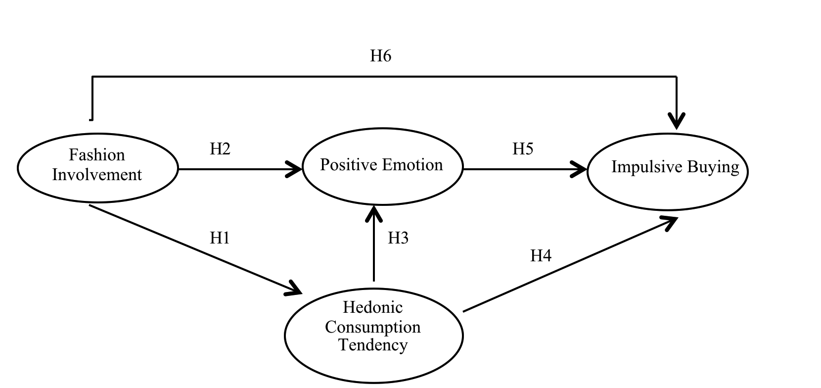

Source: (Park, Kim, & Forney, 2006) A structural model of fashion-oriented impulse buying behavior

The relationship is investigated by the following hypotheses:
H1: Fashion involvement has a significant influence on hedonic consumption tendency when shopping fashion products at ecommerce fashion Indonesia
H2: Fashion involvement has a significant influence on positive emotion when shopping fashion products at ecommerce fashion Indonesia.
H3: Hedonic consumption tendency has a significant influence on positive emotion when shopping fashion products at ecommerce fashion Indonesia.
H4: Hedonic consumption tendency has a significant influence on impulsive buying when shopping fashion products at ecommerce fashion Indonesia.
H5: Positive emotion has a positive influence on impulsive buying when shopping fashion products at ecommerce fashion Indonesia
H6: Fashion involvement has a positive influence on impulsive buying when shopping fashion products at ecommerce fashion Indonesia.

METHODS
The targeted population in this research is a female who with a range of 18 – 30 years old. According to BMI (Brand & Marketing Institute) Research, that range age are considered the top age that buy more in online context. The area population is specified in Jakarta. As the biggest metropolitan city in Indonesia, people in Jakarta tend to have more interest in the fashion industry. Therefore, choosing Jakarta, as the population of the research would portray a more comprehensive explanation related to consumer fashion online motivations in Indonesia. The population is 1.350.242.
The sampling method that will be used in this research is non-probability sampling with judgment sampling technique, judgment sampling techniques are used due to the criteria of the respondents which are female who have to shop fashion online at ecommerce fashion impulsively, lives in Jakarta, with age range from 18 - 30 years old. Subject selection is not based on the purchase of fashion goods in a particular category, because reseracher wants to see motivation impulsive buying fashion goods at fashion ecommerce overall. To determine the sample size, researcher use the Slovin’s (1960) formula with the margin error of 0.1, the sample needed is 99.99 and will be rounded to 100. Regarding the calculation 100 sample is considered sufficient to reflect the population.
The questionnaires used to gather the data was first transferred in to Ms. Excel and afterward tested using SPSS 22 for the pilot test in order to ensure its Validity and Reliability, as much as 30 respondents were tested. The second part used LISREL-SEM using LISREL 8.7 software to asses the inner model. SEM model used to solve multilevel models simultaneously that cannot be resolved by path analysis model on a linear regression equation. Researcher consider using SEM as data analysis technique to see the effect, significant level from each effect size and to prove hypothesis.

RESULTS AND DISCUSSION
The questionnaire for this research are distributed to 168 respondents, but who pass through screening questions or meet the criteria of respondents only 120 respondents who can be analyzed. This result is beyond the targeted respondents, 100 respondents. This research aims to determine what factors that influence consumers to do impulsive buying and how does relationship of theses factors influence consumers to do impulsive buying toward fashion products at e-commerce fashion Indonesia. The discussion of each research questions is presented as follows:
The factors that influence consumers to do impulsive buying are found in literature review chapter where researcher adapted the study from Park, Kim and Forney (2006) “A structural model of fashion- oriented impulse buying behavior” that provide the structural model of fashion-oriented impulsive buying behavior with fashion involvement, hedonic consumption tendency, positive emotion and impulsive buying. Yet, the context of that study is not focusing on specific area. Researcher found that these variables in Park, Kim, and Forney (2006) study can be applied in online context, which are fashion involvement, hedonic consumption tendency, positive emotion and impulsive buying. However, the indicator of each variable can be modified in online context by adapting theory from Hilal and Nil (2014) “Shopping online without thinking: being emotional or rational” and O’Cass (2004) “Fashion clothing consumption: Antecedents and consequences of fashion clothing involvement”. Eventough the variable can be applicable both in online and offline, these variables showed different result.
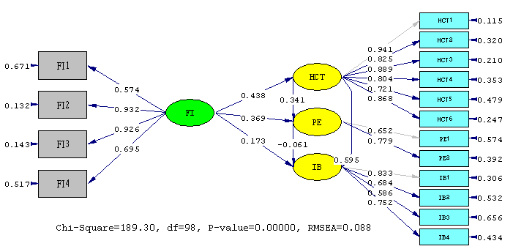

Figure 1 Structural Model ( Standardize)

Table 1 Coefficient Path
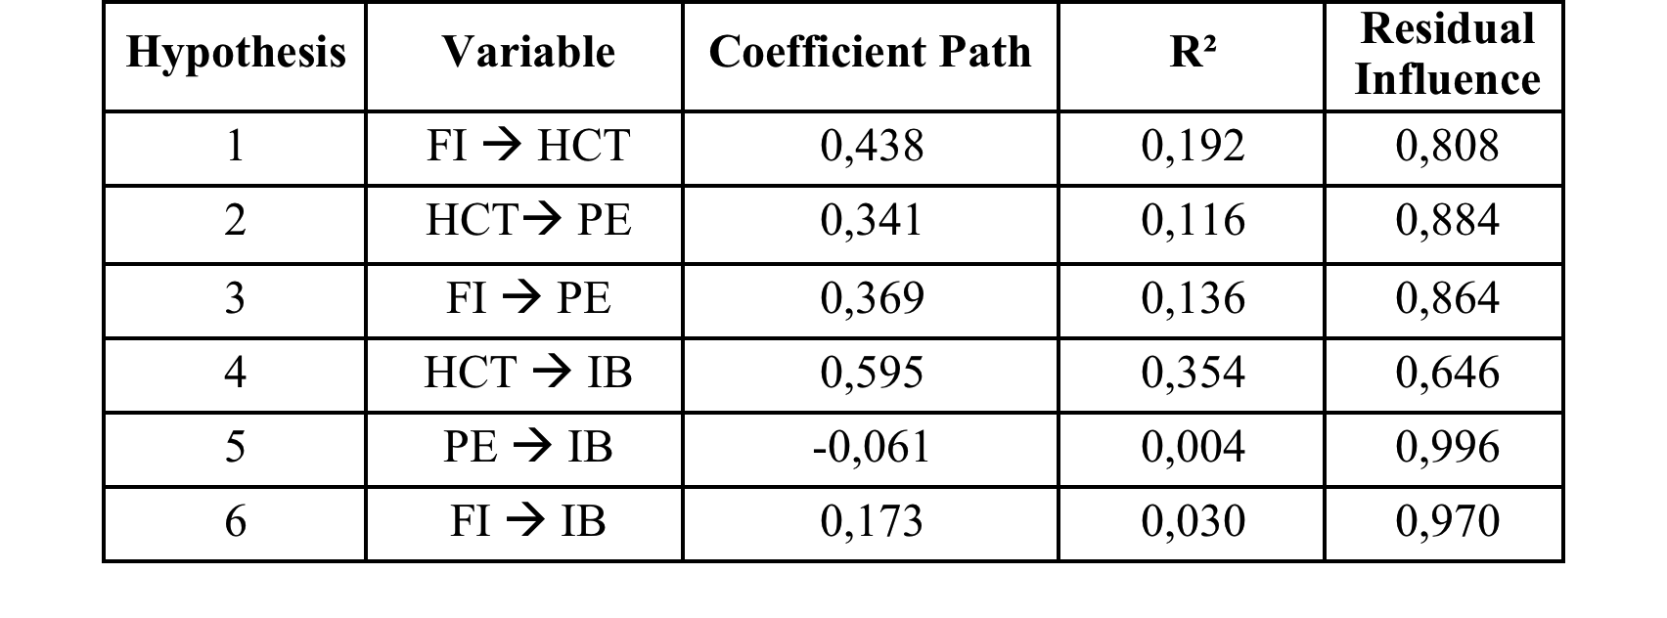

Path Analysis
From the table above, we can conclude that; (1)The influence of Fashion Involvement to Hedonic Consumption Tendency is equal to 0,192 or about 19,2% while other factor influence to Hedonic Consumption Tendency with 0,808 or about 80,8%. (2) The influence of Hedonic Consumption Tendency to Positive Emotion is equal to 0,116 or about 11,6% while other factor influence to Positive Emotion with value 0,884 or about 88,4%. (3) The influence of Fashion Involvement to Positive Emotion is equal to 0,136 or about 13,6% while other factor influence to Positive Emotion with a value of 0.864 or about 86.4%. (4) The Influence of Hedonic Consumption Tendency to Impulsive Buying is 0,354 or about 35,4% while other factor influence to Impulsive Buying with 0,646 or about 64,6%. (5) The influence of Positive Emotion to Impulsive Buying is 0,004 or about 0,4% while other factor influence to Impulsive Buying with 0,996 or about 99,6%. (6) The influence of Fashion Involvement to Impulsive Buying is 0,030 or about 3.0% while other factor influence to Impulsive Buying with 0,970 or about 97,0%.

Result of coefficient testing using LISREL:

PE = 0.341*HCT + 0.369*FI, Errorvar.= 0.637 , R² = 0.363
(0.122) (0.126) (0.211)
2.796 2.923 3.016

The influence of both hedonic consumption tendency and fashion involvement on positive emotionis shown by R square value (R2) 0,363 shows influence of hedonic consumption tendency and fashion involvement to positive emotion equal to 36,3%, the rest equal to 63,7 % influenced by other factors that are not examined.

IB = 0.595*HCT - 0.0613*PE + 0.173*FI, Errorvar.= 0.569 , R² = 0.431
(0.112) (0.134) (0.109) (0.125)
5.335 -0.457 1.589 4.553

The influence of fashion involvement, hedonic consumption tendency, and positive emotion to impulsive buying is shown by the value of R square (R2), the value of R square 0,431 shows the influence of fashion involvement, hedonic consumption tendency, and positive emotion to impulsive buying is 43.1%, the rest of 56.9% influenced by other factors that are not examined.

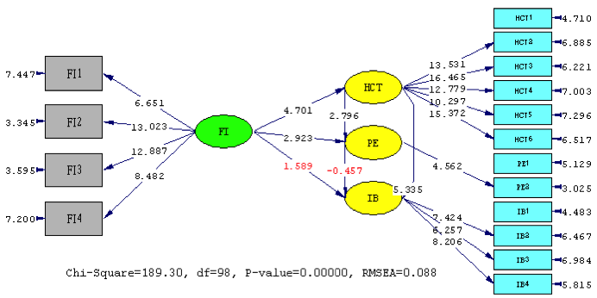
Figure 2 Structural Model (T-value)

Hypotheses Test
H1. The first hypothesis tested was the influence of fashion ivolvement to hedonic consumption tendency. T-value count is 4.701 greater than the critical limit specified that is +1,96, so H1 is supported, which means there is positive influence of fashion involvement to hedonic consumption tendency. This is because consumers who care and love the fashion world usually have a high involvement with the latest fashion because they will try to follow the trend and fashion, they will also try to meet their fashion needs by shopping for fashion products or dress in a way that is unique and interesting. However, it supported by e-commerce fashion which provide various types of fashion products from various brands so consumers have many options to fulfill their involvement in fashion. The results support previous by Park, Kim and Forney (2006) findings that consumers who have a special involvement in fashion products usually lead to hedonic consumption tendency because the higher level of consumer involvement with fashion products, the more they will increase the purchase of fashion products.
H2. The second hypotheses tested was the influence of fashion ivolvement to hedonic consumption tendency. The value of t-value 2,796 is greater than the specified critical limit is +1,96, so H2 is supported, which means there is significant influence of fashion involvement to positive emotion. This is because consumers with positive emotions more can reflect the extent to which a person in high energy conditions, full concentration, and pleasant engagement with certain product items as well as consumers are very enthusiastic with the varied fashion models and satisfied with the quality of fashion products. This can happen when the consumer is happy when the consumer can easily find the product model of fashion that matches her taste. These results support previous research by Park, Kim, and Forney (2006) which suggests that fashion involvement influences positive emotions because fashion involvement can enhance the consumer's emotional experience when shopping and positive emotions can increase as consumers feel very excited and satisfied during shopping and when they are able to express their curiosity towards fashion products.
H3. The third hypotheses tested was the influence of fashion ivolvement to positive emotion. The value of t-value 2,923 is greater than the specified critical limit is +1,96, so H3 is supported, which means there is significant influence of fashion involvement to positive emotion. It indicating that the higher the value of hedonic consumption tendency the higher the positive emotions. This means conformity with supporting theories, Park and Stoel (2005) explained that consumers feel more enthusiastic and satisfied during shopping when they show curiosity, the need to experience new experiences, and feelings of exploring new worlds. These findings support the involvement of hedonic motivation in meeting emotional satisfaction. A pleasant experience when shopping can be caused by the fulfillment of emotional desire, in order to reduce or even eliminate negative feelings to the consumer. The results of this study also supports research conducted by Park, Kim and Forney (2006) stated the hedonic consumption tendency has a positive effect on positive emotions.
H4. The fourth hypotheses tested was the influence of hedonic consumption tendency to impulsive buying. The t-value 5.335 is greater than the critical limit specified that is +1,96, so H4 is supported, which means there is significant influence of hedonic consumption tendency to impulsive buying. It indicating that high hedonic consumption tendency, the higher the impulse buying. Hedonic consumption tendency has been defined as the behavioral aspects associated with multisensory, fantasy, and emotional aspects of consumption. This view shows that consumption is driven by the pleasure experienced by consumers in using online media. The hedonic consumption tendency refers to the sense of enjoyment and pleasure that consumers receive from all purchasing experiences associated with online shopping activities. The presence of a sense of pleasure consumers when shopping online will cause impulse buying. The results of this study support the research that has been done by Hilal and Nil (2014) which shows that the hedonic consumption tendency influences impulse buying.
H5. The fifth hypothesis tested was the influence of positive emotion to hedonic consumption tendency. The value of t-value is -0.457 greater than the critical limit specified that is , -1.96, so H5 is rejected, which means there is no significant influence of positive emotion on online impulsive buying. This result is opposite with previous research by (Beatty & Ferrell, 1998) suggest that impulse purchases come from greater feelings, pleasure, enthusiasm, and joy. It may be because when shopping in the store people can experience the real shopping experience such as try to put clothes on, or the ambiance of the store itself which lead to positive emotion. In fact, the quality of decisions are depend on emotions, and people with emotional deficits often make worse decisions than people without such deficits; but emotions can lead to biased judgments, too, when they are used as a shortcut in the decision making process (Loewenstein & Lerner, 2003). Impulsive buying as less rational decision making which take a quick decision when buying products might lead to this phenomena when negative emotion occurs. It supported by Moran, Bryant and Kwak (2015) stated that consumers under stress will have a higher online impulse- buying tendency than those under no stress.
H6. The last hypothesis tested was the influence of fashion involvement to impulsive buying
The value of t-value is 1.589 lower than the critical limit specified that is +1,96, so H6 is rejected, which means there is no significant influence fashion involvement on impulsive buying. This means fashion involvement is not really factors that influence consumers to buy fashion impulsively at e-commerce Indonesia. Its different from study by Park, Kim and Forney (2006) stated that fashion involvement has a signifcant influence on impulsive buying. It may be because consumers are now more likely to have another desire to buy fashion online, not just influenced by fashion involvement. From this result it is possible that consumers who buy fashion product impulsively at e-commerce Indonesia are not only consumers who have high fashion involvement.

Direct and Indirect Influence

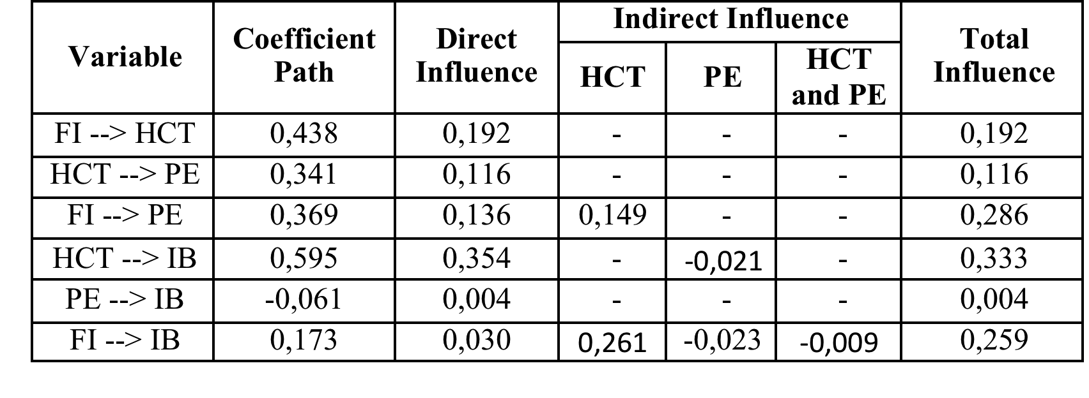
Table 1.2 Direct and Indirect Influence

The result shows that hedonic consumption tendency has the strongest influence to impulsive buying (total influence of 0.333), followed by fashion influence to impulsive buying (total influence of 0.259). Meanwhile, positive emotion has weak influence toward impulsive buying (total influence of 0.004). This finding shows that hedonic consumption tendency has become the main factor contributing to do impulsive buying and has high influence to do impulsive buying directly, while fashion involvement has high influence towards impulsive buying indirectly.

CONCLUSIONS
This study examines the effects of factor that causing impulsive buying toward fashion products at ecommerce fashion Indonesia such as Zalora, Berrybenka, Bobobobo, and Localbrandid. Moreover, this study also examines the relationship among variables. After the research has been conducted, researcher able to answer the research question that stated on chapter one. Based on the literature review that researcher gathered the factors that influence consumers to do impulsive buying toward fashion products at ecommerce Indonesia are fashion involvement, positive emotion, hedonic consumption tendency (in online context), and the impulsive buying itself. In this study, there is also some different, but interesting finding about the relationship between these variable on impulsive buying. Hedonic consumption tendency has a positive influence toward impulsive buying. Meanwhile, fashion involvement has no significant influence toward impulsive buying. Moreover, positive emotion has negative influence on impulsive buying at e-commerce. Therefore, marketers should concern about hedonic consumption tendency in order to make marketing strategies on fashion products through e-commerce context.
There are several recommendations addressed to ecommerce fashion Indonesia with the findings of this study as well as the managerial implications of this study. Because of the significant influence of hedonic consumption variable both directly and indirectly on impulse buying at e-commerce fashion Indonesia. Ecommerce fashion Indonesia such are expected to learn and understand the hedonic online consumption tendency as significant factor that drive consumers to do impulsive buying, it aims to bring up creative ideas in creating marketing strategies to engage their hedonic motivation by offering unique promises and best pricing. The management of e-commerce fashion must be able to create hedonic shopping atmosphere through their website, specifically by offering well-attached program or promo such as bundle promo, the discounts, the free delivery service as well as the warranty. Free shipping is also a favorite of consumers especially in online context. It aims to boost up consumers’ hedonic consumption tendency so that the consumers are motivated in shopping impulsively of the fashion products.
Also, the fashion involvement considered as the significant variable that can be indirectly affect on impulsive buying. Although fashion involvement is not significant variable but the involvement of fashion can influence consumers to buy impulsively with other variables such as the existence of hedonic consumption tendency or the emergence of positive emotions on the relevance of the fashion product. Therefore, ecommerce fashion Indonesia expected to be more creative to create programs that can increase the involvement of fashion such as provide information about the upcoming collection, the new collection or even the look-book of the collection. Moreover, e-commerce fashion Indonesia as e-retailers can also add more variety of their up-to-date fashion products since consumers tend to follow the trend.
This study has several limitations that are used as consideration for further research. First, the variables that are used in this study are limited (fashion involvement, positive emotion, and hedonic consumption tendency). Adding the variables are needed to explore the impulsive buying behavior for fashion products. This can add information about the factors that drive consumer impulse behavior. Second, the object of this study is limited to fashion products, thus giving generalization limitations of the research results. Further research can be done on other objects such as automotive products, electronics and cosmetics. The last, in addition to using questionnaire techniques, it can also develop with interview technique to know consumer factors to do impulse buying so that data obtained more complete and can reduce data, which is subjective.

REFERENCES

Rook. (1987). The Buying Impulsive. The Journal of Consumer Research , 14, 189-199.
Jones, M. A., Reynolds, K. E., Weun, S., & Beatty, S. E. (2003). The product-specific nature of impulse buying tendency. Journal of Business Research , 56 (7), 505-511.
Donthu, N., & Garcia, A. (1999). The Internet Shopper. Journal of Advertising Research , 39 (3), 52-58.
Dittmar, H., Long, K., & Meek. (2004). Buying on the internet: gender differences in online and conventional buying motivations, sex roles. 50, 423-444.
Jones, K., & Leonard, L. N. (2009). Consumer-to-Consumer Electronic Commerce: A Distinct Research Stream. Journal of Electronic Commerce in Organizations , 39-54.
Youn, & Faber. (2000). Impulse buying: its relation to personality traits and cues. Advances in Consumer Research , 27, 179-85.
Piron, F. V. (1993). A Comparison of Emotional Reactions Experienced by Planned, Unplanned and Impulse Buying Behavior. Journal of Fashion Marketing and Management , 10.
Babin, B., Darden, W., & Griffin, M. (1994). Work and or Fun: Measuring Hedonic and Utilitarian Shopping Value. Journal of Consumer Research , 644-656.
Hausman, A. (2000). A Multi-method Investigation of Consumer Motivations in Impulse Buying Behaviour. Journal of Consumer Marketing , 17 (5), 403-419.
Dennis, C., Meerilees, W., Jayawardhena, C., & Wright, L. (2009). E-Consumer Behaviour. European Journal of Marketing , 43 (9/10), 1121-1139.
Wolfinbarger, M., & Gilly, M. C. (2003). eTailQ: Dimensionalizing, Measuring, and Predicting eTail Quality. Journal of Retailing , 79 (3), 183-198.
Childers T, L., Carr, C., Peck, J., & Carson, S. (2001). Hedonic and Utilitarian motivations for online retail shopping behavior. Journal of Retailing , 77, 511-535.
Hirschman, E., & Holbrook, M. (1982). Hedonic consumption: emerging concepts, methods, and proportions. Journal of Marketing , 46 (2), 92-101.
Park, J., & Stoel, L. (2005). Effect of brand familiarity, experience and information on online apparel purchase. International Journal of Retail and Distribution Management , 33 (2), 148-160.
Kukar-Kinney, M., Ridgway, N., & Monroe, K. (2009). The Relationship Between Consumers’ Tendencies to Buy Compulsively and Their Motivations to Shop and Buy on the Internet. Journal of Retailing , 85 (3), 298-307 .
O'Cass, A. (2004). Fashion clothing consumption: Antecedents and consequences of fashion clothing involvement. European Journal of Marketing; Bradford , 38 (7), 869-882.
Park, E. J., Kim, E. Y., & Forney, J. C. (2006). A structural model of fashion- oriented impulse buying behaviour. Journal of Fashion Marketing and Management , 433- 446.
Beatty, S., & Ferrell, M. (1998). Impulse buying: Modeling its precursors. Journal of Retailing , 74 (2), 169-91.
Rook, D. W., & Gardner, M. P. (1993). In the mood: impulse buying s affective antecedents. 6, 1-26.
Hilal, O., & Nil, E. (2014). Shopping online without thinking: being emotional or rational. Asia Pasific Journal Marketing and Logistics , 1 (26), 78-93.

